# Talend JSON complex structure Parsing and Loading

**--By AMEY PARANGE**

**Part1: Loading Json**

**Actors Json : wf_load_actors**

**DB snapsot**

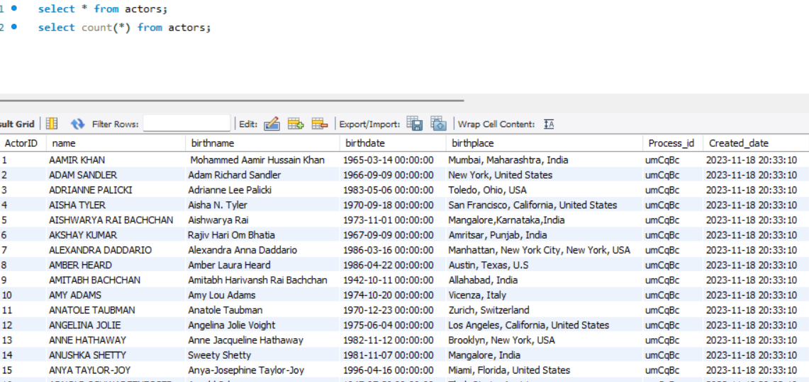

**Directors Json: wf_load_directors**

**DB Snapshot**

**Movies Json: wf_load_movie_details_org**

**DB Snapshots**

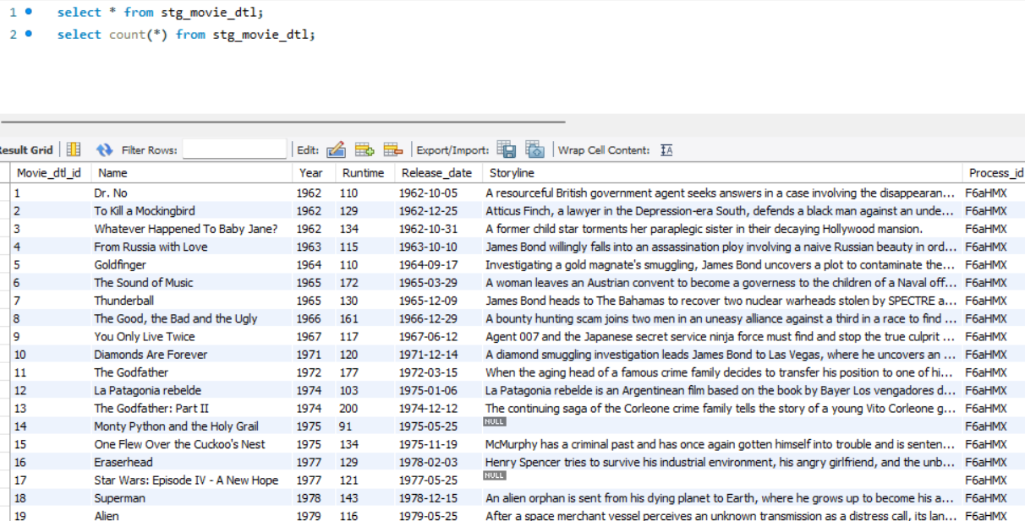

**Datamart Implementation**

**wf_load_dim_movie**

**wf_load_fct_movie**

**wf_load_dim_actors**

**wf_load_dim_actors_from_stg_actors**

**Wf_load_dim_directors**

**wf_load_dim_director_from_stg_director**

**wf_load_dim_category**

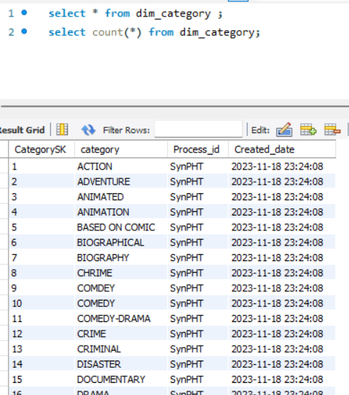

**wf_load_dim_writer**



